Big Data on AWS v3.0: Lab 2 - Using Amazon Athena to Analyze Log Data

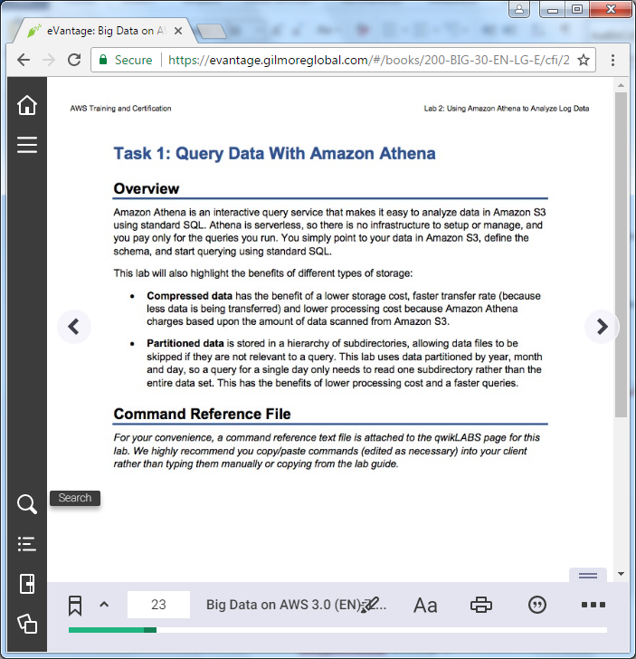

==================================================================================================================

Using this command reference.

==================================================================================================================

1. Locate the section you need. Each section in this file matches a section in the lab instructions.

2. Replace items in angle brackets - < > - with appropriate values. For example, in this command you would replace the value - <JobFlowID> - (including the angle brackets) with the parameter indicated in the lab instructions:

elastic-mapreduce --list <JobFlowID>. You can also use find and replace to change bracketed parameters in bulk.

3. Do NOT enable the Word Wrap feature in Windows Notepad or the text editor you use to view this file.

==================================================================================================================

Task 1: Query Data with Amazon Athena

==================================================================================================================

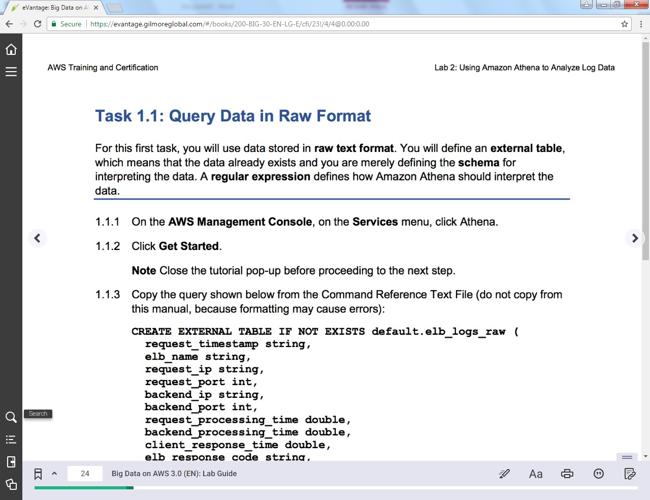

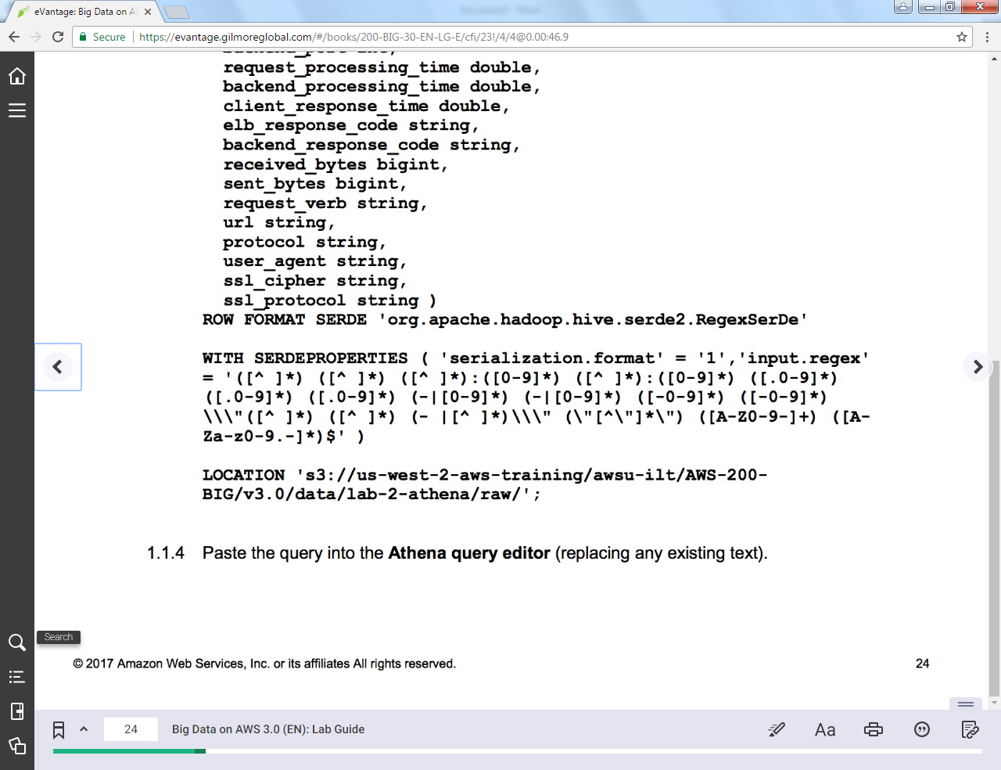

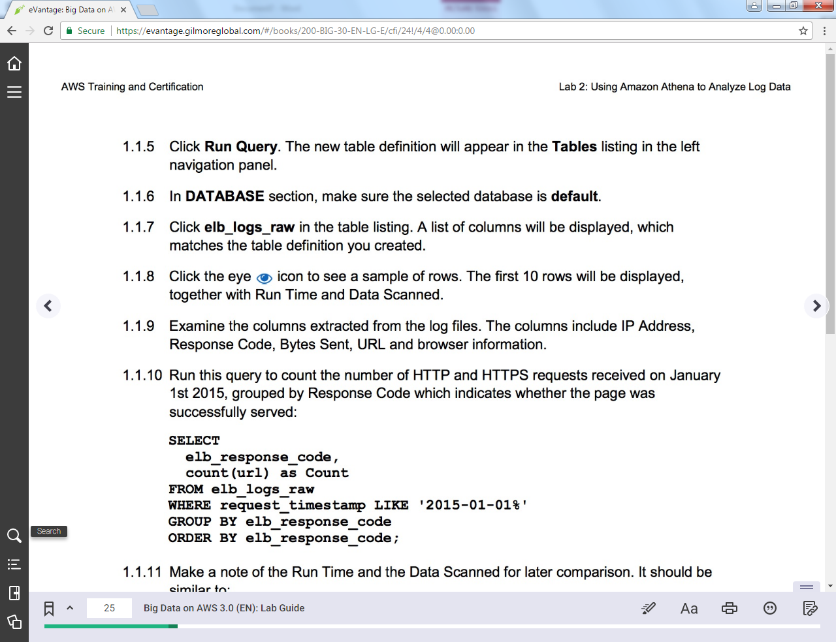

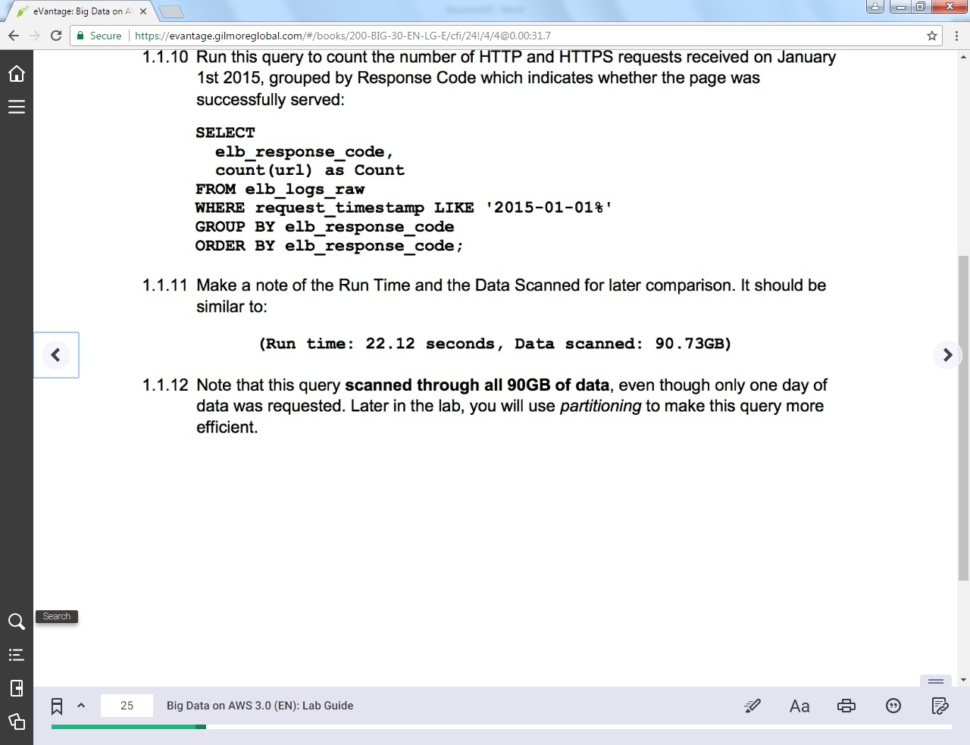

+++ Step 1.1.2

CREATE EXTERNAL TABLE IF NOT EXISTS default.elb_logs_raw (

request_timestamp string,

elb_name string,

request_ip string,

request_port int,

backend_ip string,

backend_port int,

request_processing_time double,

backend_processing_time double,

client_response_time double,

elb_response_code string,

backend_response_code string,

received_bytes bigint,

sent_bytes bigint,

request_verb string,

url string,

protocol string,

user_agent string,

ssl_cipher string,

ssl_protocol string )

ROW FORMAT SERDE 'org.apache.hadoop.hive.serde2.RegexSerDe'

WITH SERDEPROPERTIES ( 'serialization.format' = '1','input.regex' = '([^ ]*) ([^ ]*) ([^ ]*):([0-9]*) ([^ ]*):([0-9]*) ([.0-9]*) ([.0-9]*) ([.0-9]*) (-|[0-9]*) (-|[0-9]*) ([-0-9]*) ([-0-9]*) \\\"([^ ]*) ([^ ]*) (- |[^ ]*)\\\" (\"[^\"]*\") ([A-Z0-9-]+) ([A-Za-z0-9.-]*)$' )

LOCATION 's3://us-west-2-aws-training/awsu-ilt/AWS-200-BIG/v3.0/data/lab-2-athena/raw/';

+++ Step 1.1.8

SELECT

elb_response_code,

count(url) as Count

FROM elb_logs_raw

WHERE request_timestamp LIKE '2015-01-01%'

GROUP BY elb_response_code

ORDER BY elb_response_code;

==================================================================================================================

Task 1.2: Query Compressed Data

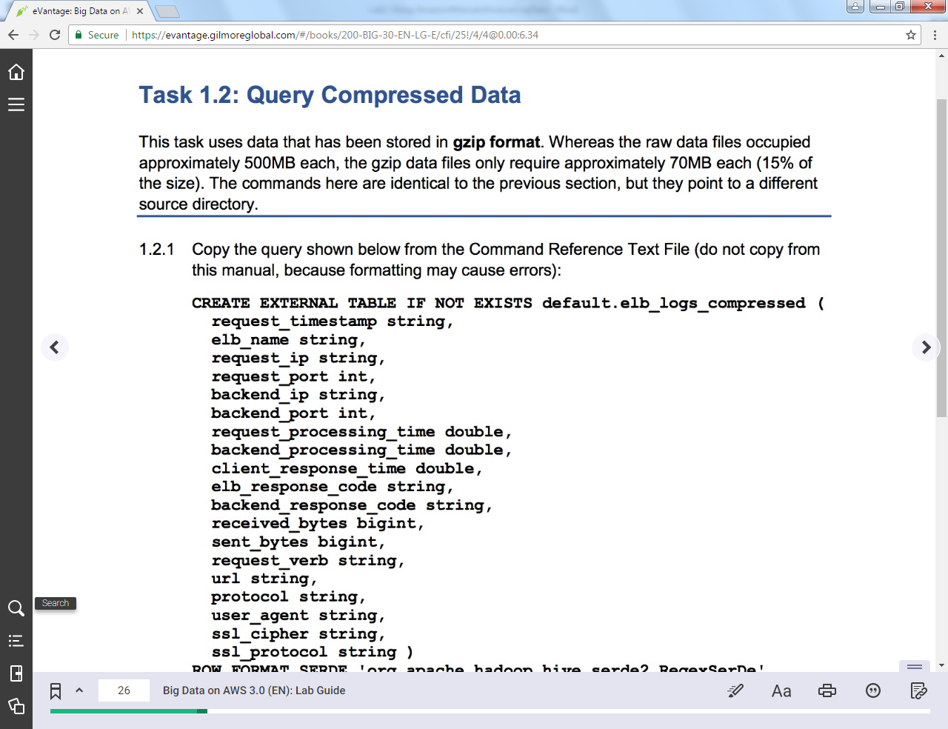

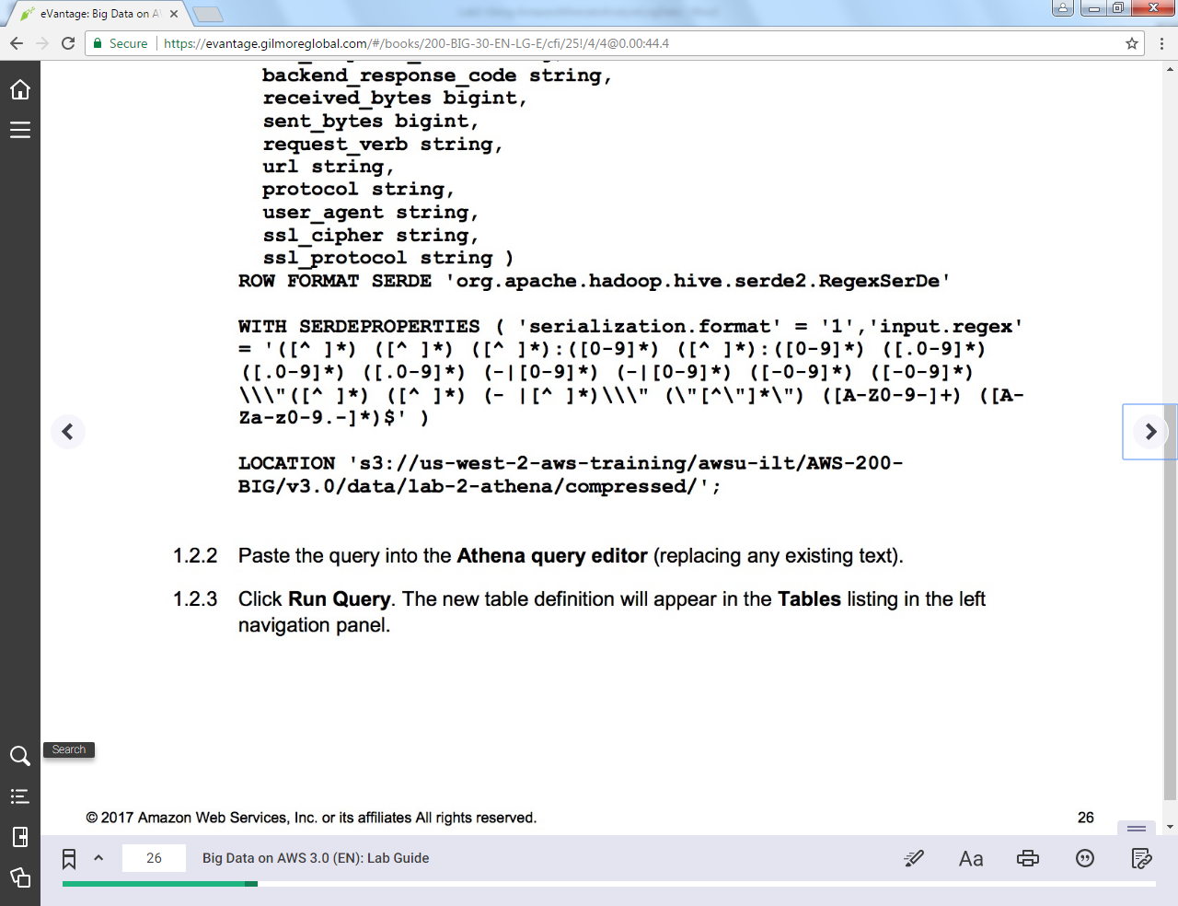

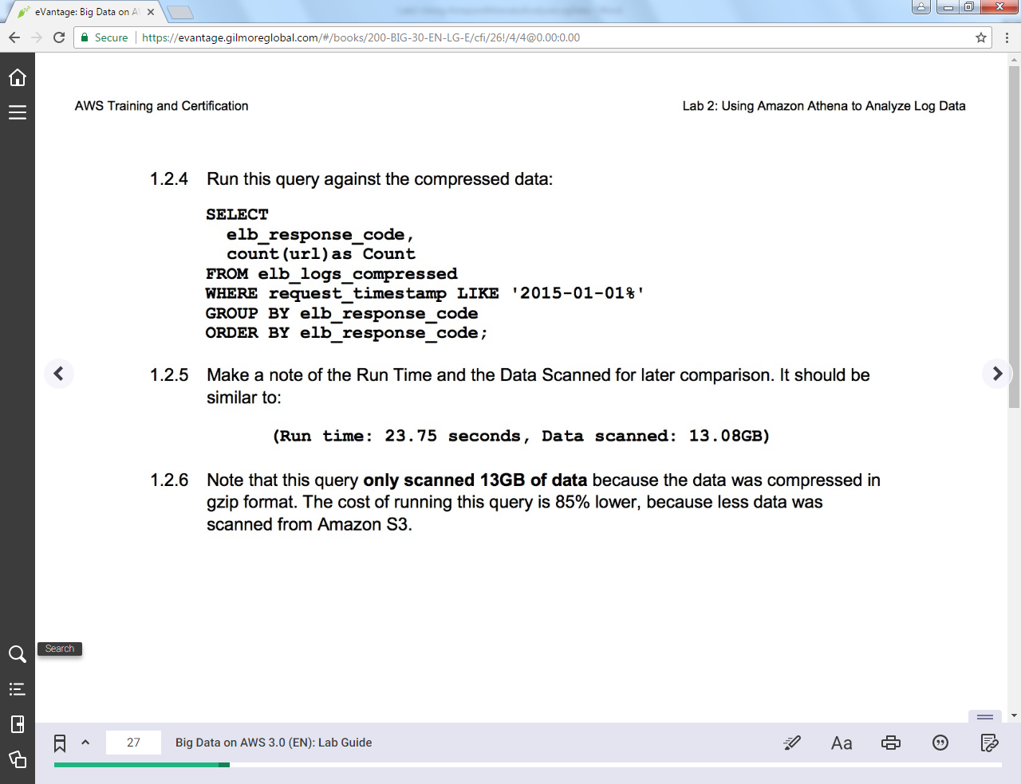

=====================================

+++ Step 1.2.1

CREATE EXTERNAL TABLE IF NOT EXISTS default.elb_logs_compressed (

request_timestamp string,

elb_name string,

request_ip string,

request_port int,

backend_ip string,

backend_port int,

request_processing_time double,

backend_processing_time double,

client_response_time double,

elb_response_code string,

backend_response_code string,

received_bytes bigint,

sent_bytes bigint,

request_verb string,

url string,

protocol string,

user_agent string,

ssl_cipher string,

ssl_protocol string )

ROW FORMAT SERDE 'org.apache.hadoop.hive.serde2.RegexSerDe'

WITH SERDEPROPERTIES ( 'serialization.format' = '1','input.regex' = '([^ ]*) ([^ ]*) ([^ ]*):([0-9]*) ([^ ]*):([0-9]*) ([.0-9]*) ([.0-9]*) ([.0-9]*) (-|[0-9]*) (-|[0-9]*) ([-0-9]*) ([-0-9]*) \\\"([^ ]*) ([^ ]*) (- |[^ ]*)\\\" (\"[^\"]*\") ([A-Z0-9-]+) ([A-Za-z0-9.-]*)$' )

LOCATION 's3://us-west-2-aws-training/awsu-ilt/AWS-200-BIG/v3.0/data/lab-2-athena/compressed/';

+++ Step 1.2.4

SELECT

elb_response_code,

count(url)

FROM elb_logs_compressed

WHERE request_timestamp LIKE '2015-01-01%'

GROUP BY elb_response_code

ORDER BY elb_response_code;

==================================================================================================================

Task 1.3: Querying Your Data

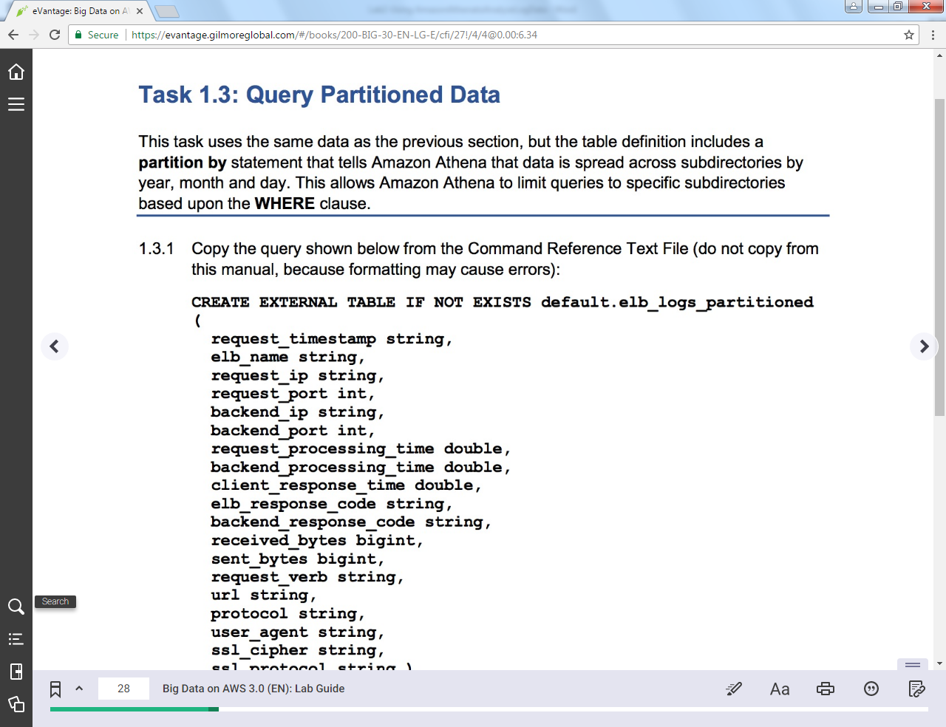

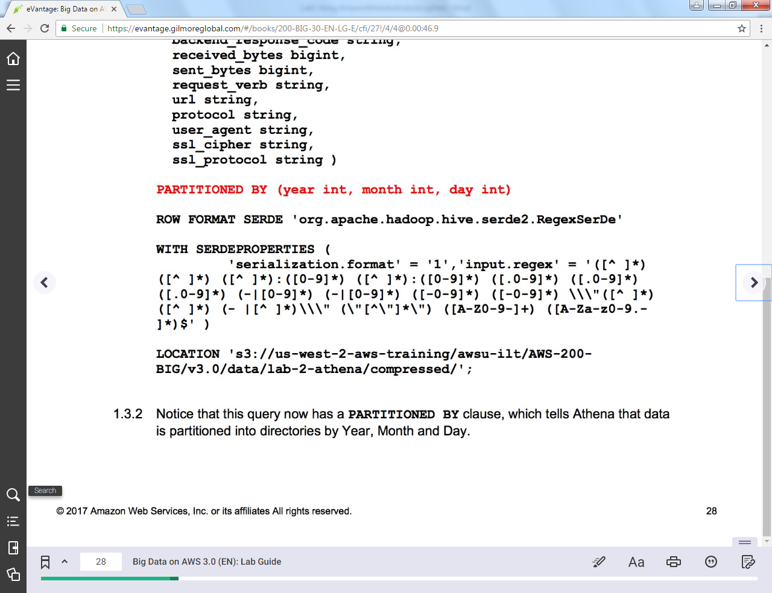 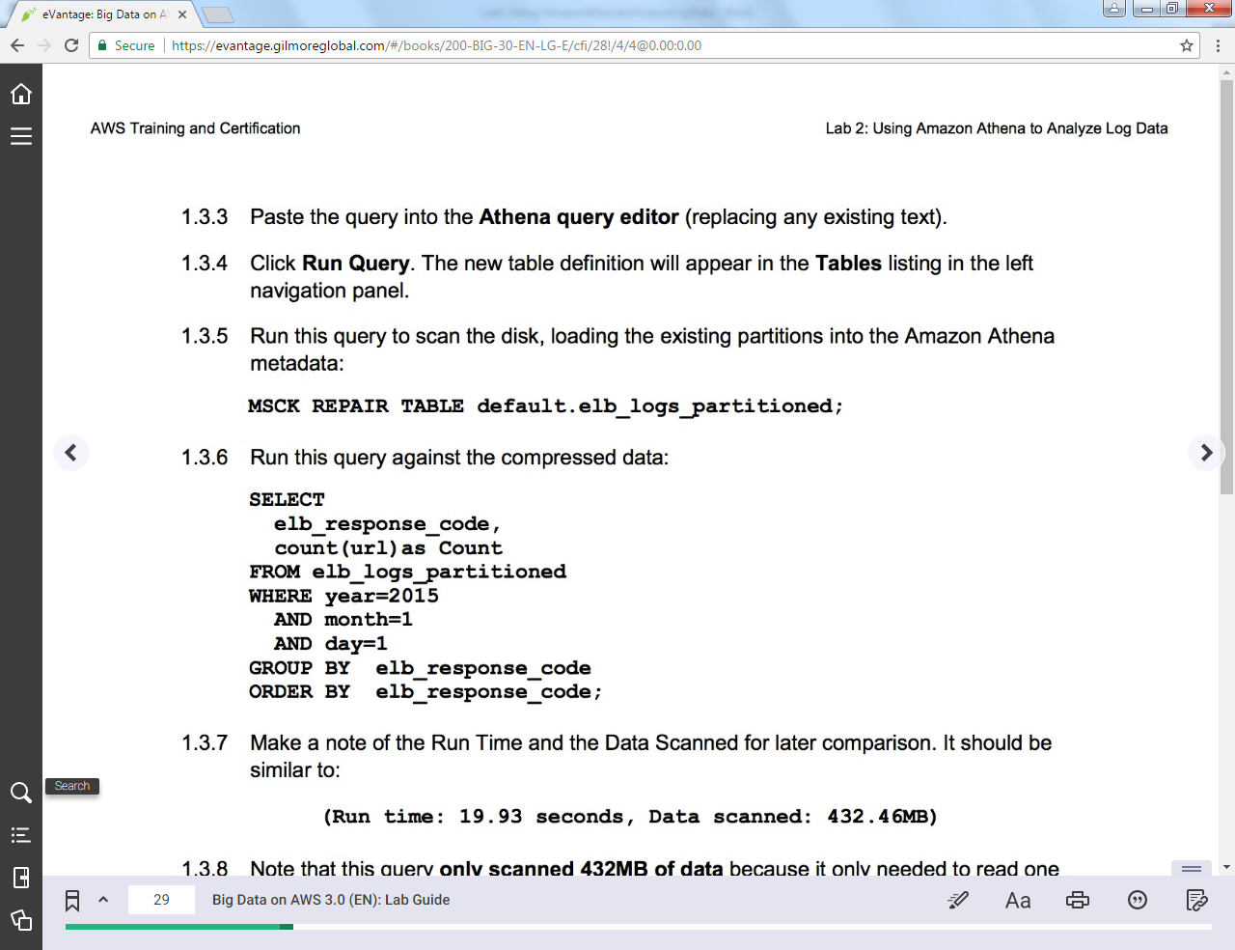 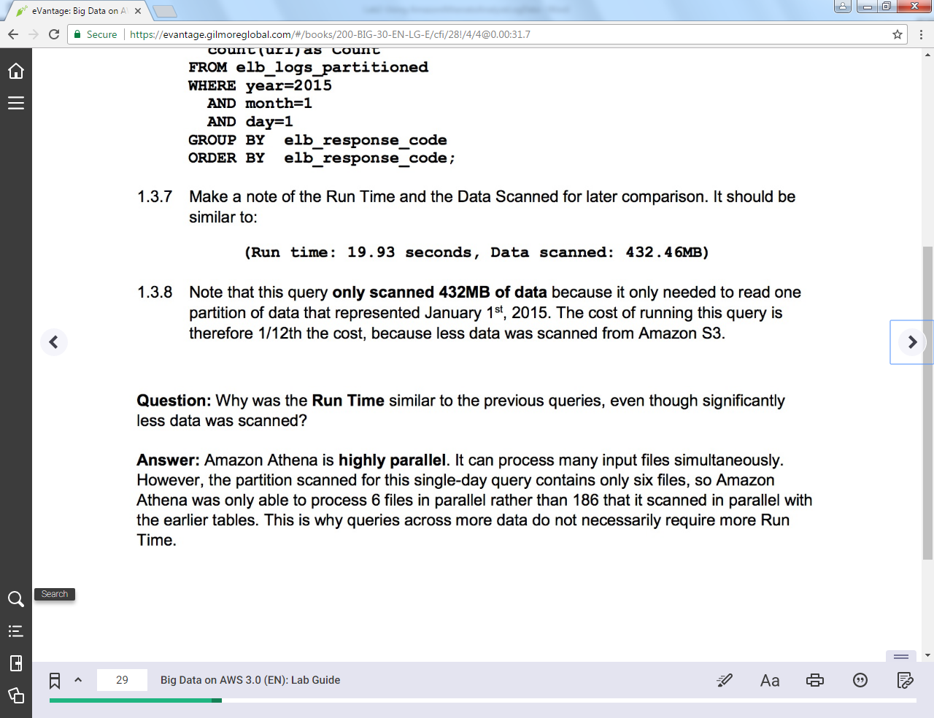

=====================================

+++ Step 1.3.1

CREATE EXTERNAL TABLE IF NOT EXISTS default.elb_logs_partitioned (

request_timestamp string,

elb_name string,

request_ip string,

request_port int,

backend_ip string,

backend_port int,

request_processing_time double,

backend_processing_time double,

client_response_time double,

elb_response_code string,

backend_response_code string,

received_bytes bigint,

sent_bytes bigint,

request_verb string,

url string,

protocol string,

user_agent string,

ssl_cipher string,

ssl_protocol string )

PARTITIONED BY (year int, month int, day int)

ROW FORMAT SERDE 'org.apache.hadoop.hive.serde2.RegexSerDe'

WITH SERDEPROPERTIES ('serialization.format' = '1','input.regex' = '([^ ]*) ([^ ]*) ([^ ]*):([0-9]*) ([^ ]*):([0-9]*) ([.0-9]*) ([.0-9]*) ([.0-9]*) (-|[0-9]*) (-|[0-9]*) ([-0-9]*) ([-0-9]*) \\\"([^ ]*) ([^ ]*) (- |[^ ]*)\\\" (\"[^\"]*\") ([A-Z0-9-]+) ([A-Za-z0-9.-]*)$' )

LOCATION 's3://us-west-2-aws-training/awsu-ilt/AWS-200-BIG/v3.0/data/lab-2-athena/compressed/';

+++ Step 1.3.5

MSCK REPAIR TABLE default.elb_logs_partitioned;

+++ Step 1.3.6

SELECT

elb_response_code,

count(url)

FROM elb_logs_partitioned

WHERE year=2015

AND month=1

AND day=1

GROUP BY elb_response_code

ORDER BY elb_response_code;

==================================================================================================================

Task 1.4: Query Columnar Data

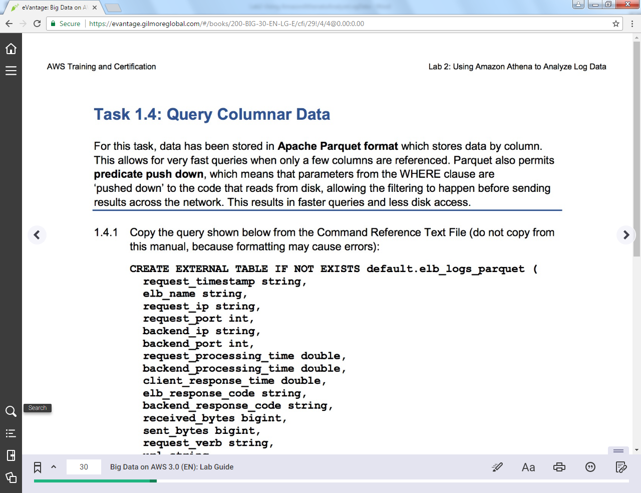 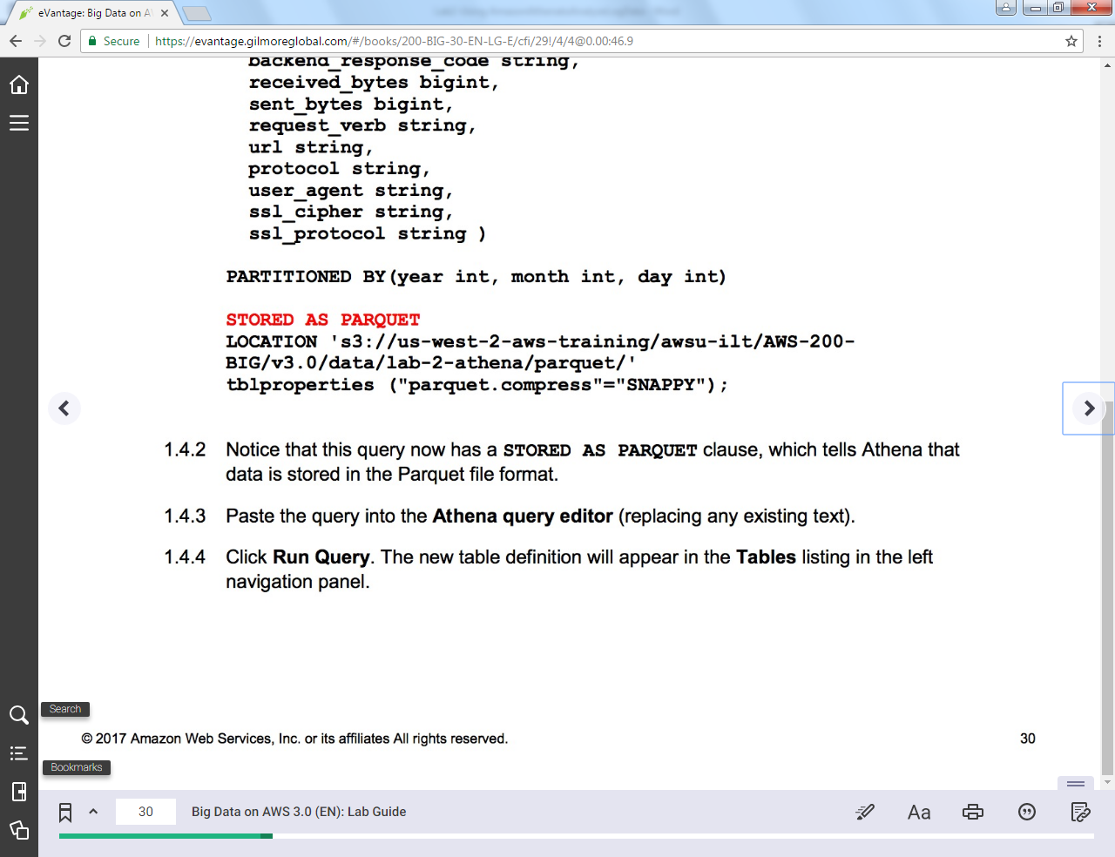 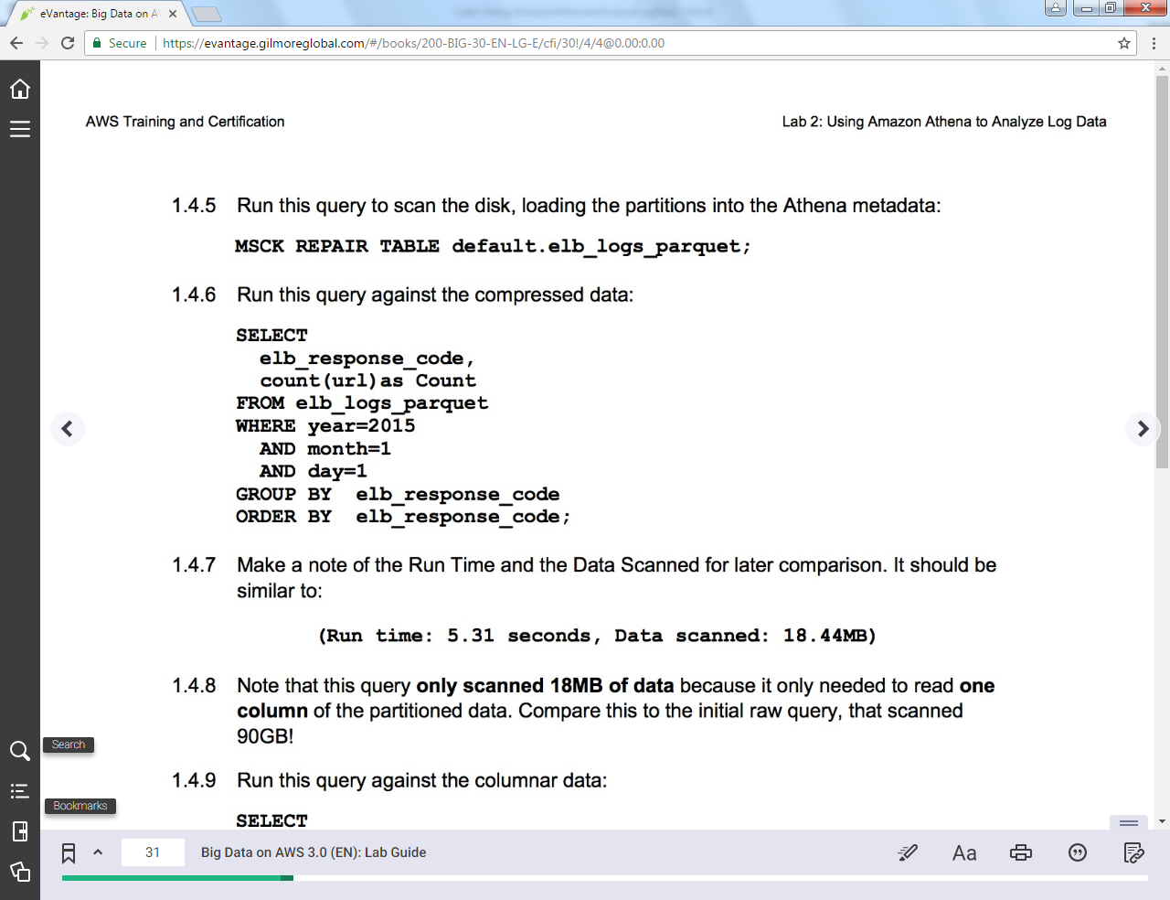 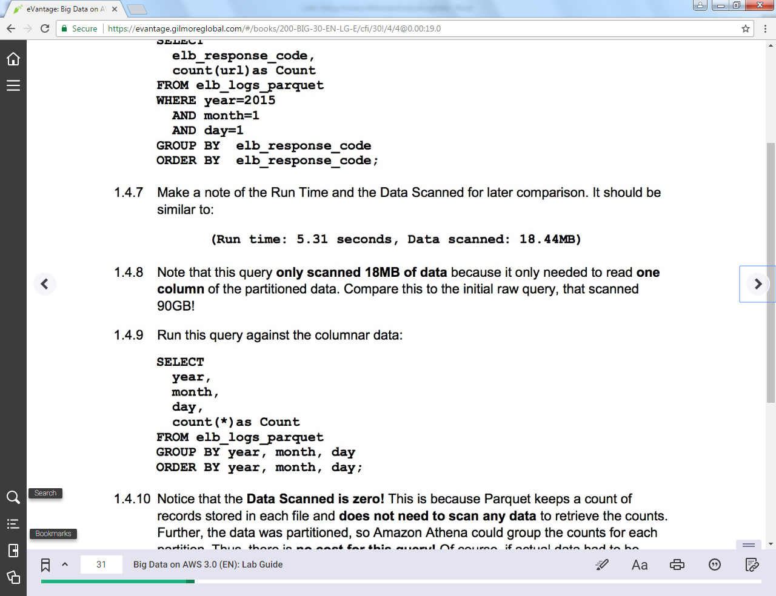 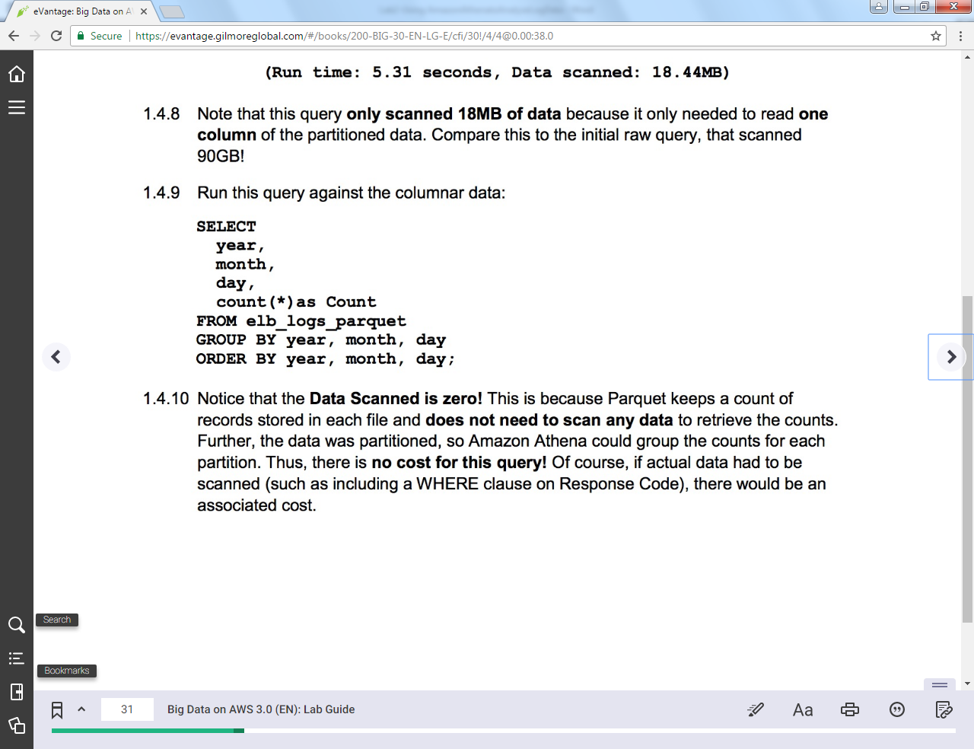 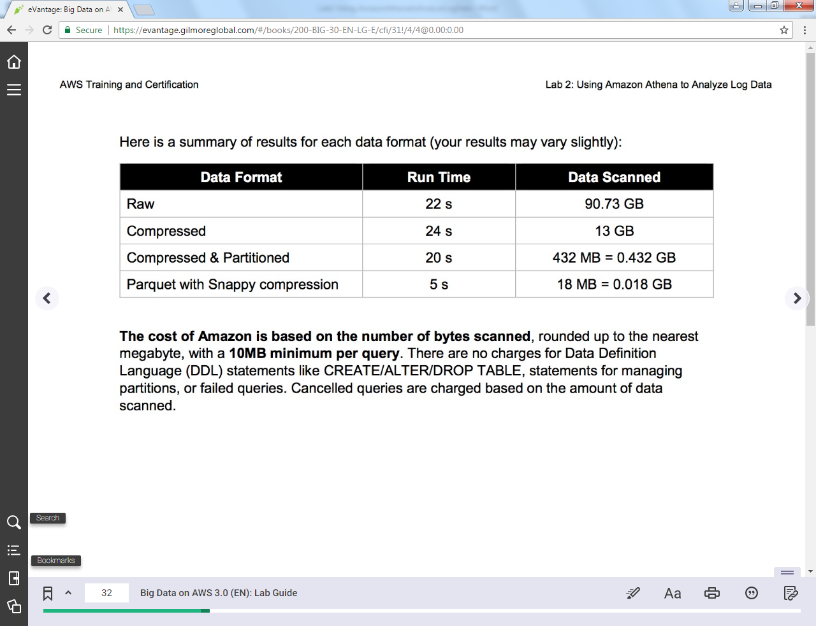=====================================

+++ Step 1.4.1

CREATE EXTERNAL TABLE IF NOT EXISTS default.elb_logs_parquet (

request_timestamp string,

elb_name string,

request_ip string,

request_port int,

backend_ip string,

backend_port int,

request_processing_time double,

backend_processing_time double,

client_response_time double,

elb_response_code string,

backend_response_code string,

received_bytes bigint,

sent_bytes bigint,

request_verb string,

url string,

protocol string,

user_agent string,

ssl_cipher string,

ssl_protocol string )

PARTITIONED BY(year int, month int, day int)

STORED AS PARQUET

LOCATION 's3://us-west-2-aws-training/awsu-ilt/AWS-200-BIG/v3.0/data/lab-2-athena/parquet/'

tblproperties ("parquet.compress"="SNAPPY");

+++ Step 1.4.5

MSCK REPAIR TABLE default.elb_logs_parquet;

+++ Step 1.4.6

SELECT

elb_response_code,

count(url) as Count

FROM elb_logs_parquet

WHERE year=2015

AND month=1

AND day=1

GROUP BY elb_response_code

ORDER BY elb_response_code;

+++ Step 1.4.9

SELECT

year,

month,

day,

count(*)

FROM elb_logs_parquet

GROUP BY year, month, day

ORDER BY year, month, day;

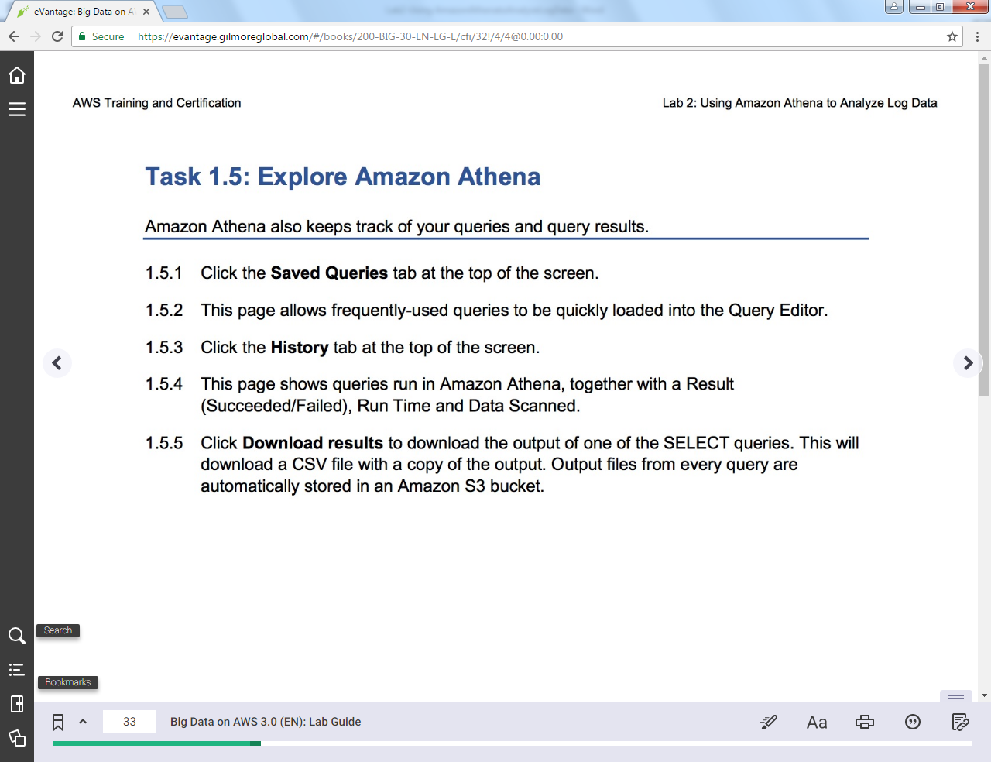

=====================================

Task 1.6: Query Columnar Data

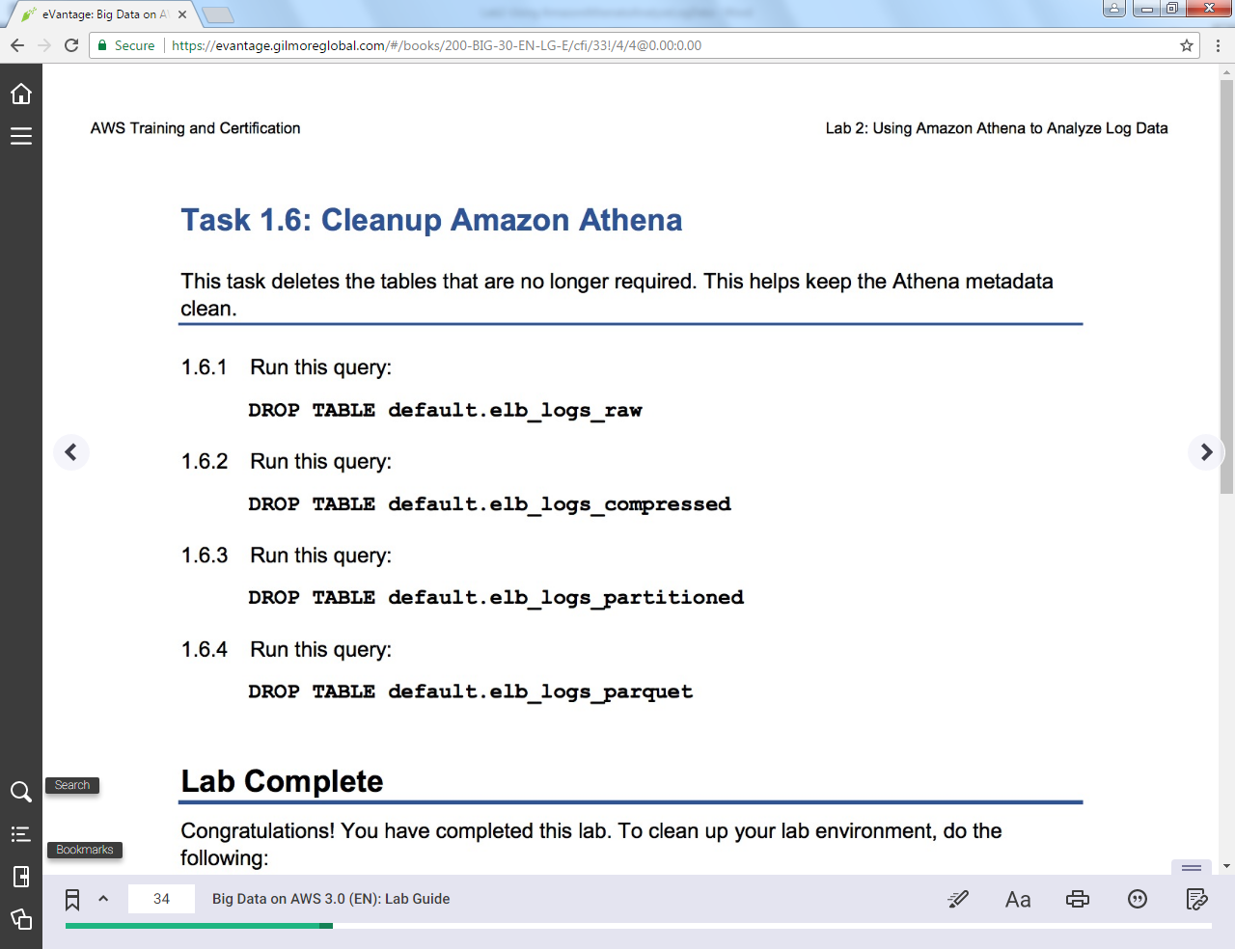

=====================================

+++ Step 1.6.1

DROP TABLE default.elb_logs_raw

+++ Step 1.6.2

DROP TABLE default.elb_logs_compressed

+++ Step 1.6.3

DROP TABLE default.elb_logs_partitioned

+++ Step 1.6.4

DROP TABLE default.elb_logs_parquet

Â© 2017 Amazon Web Services, Inc. or its affiliates. All rights reserved.